| **Test Name** | | | User Can Change Their Favourited Sensor Location | | | |
| --- | --- | --- | --- | --- | --- | --- |
| **Use Case Tested:** | | | Change Favourited Sensor | | | |
| **Test Description:** | | | The user navigates to a single sensor and then selects the favourite option, confirms and the favourite location is updated. | | | |
| **Pre-conditions** | | |  | | | |
| **Post-conditions** | | | The dashboard Favourite location should update from One Favourite Option to the selected favourite | | | |
| **Notes:** | | **Unsure how else to demonstrate a button click other than through screenshots.** | | | | |
| **Result (Pass/Fail/Warning/Incomplete)** | | **Pass** | | | | |
|  | **TEST STEP** | | | **EXPECTED TEST RESULTS** | P | F |
|  | Click On Sensors On Menu | | | All Sensors Window Is Displayed | X |  |
|  | Select A Sensor from either list | | | Single Sensor Is Displayed | X |  |
|  | Select the “Favourite?” option by the top of the window | | | The favourite option ticks | X |  |
|  | Select Yes On The Popup Window | | | Popup goes away, favourite is updated | X |  |
|  | Select The Home Option In the Menu | | | Shows The Home Page | X |  |
|  | Check The Favourite Location | | | Favourite Location has Updated | X |  |

**Test Output Screenshots**

Start

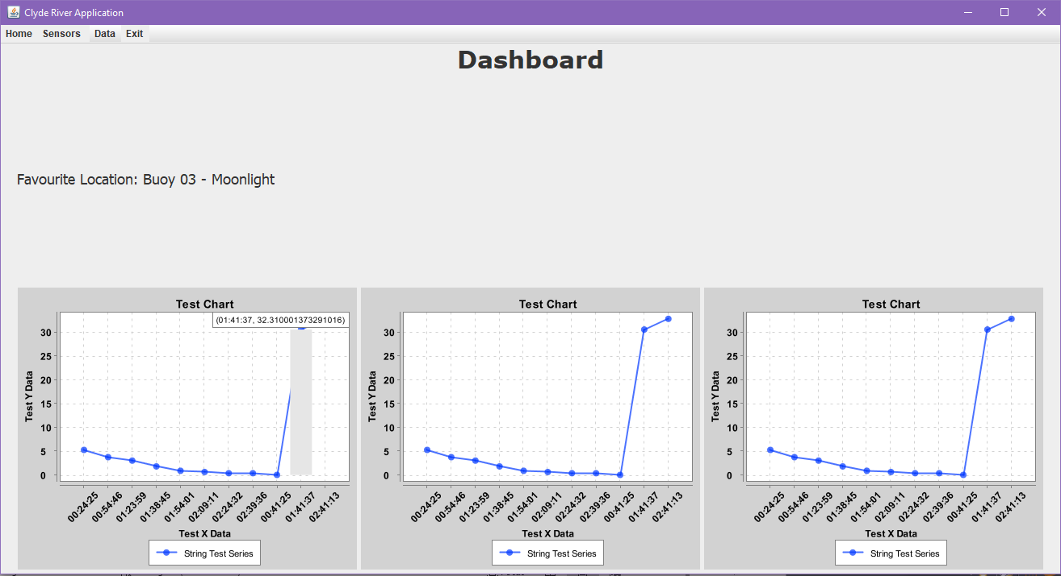

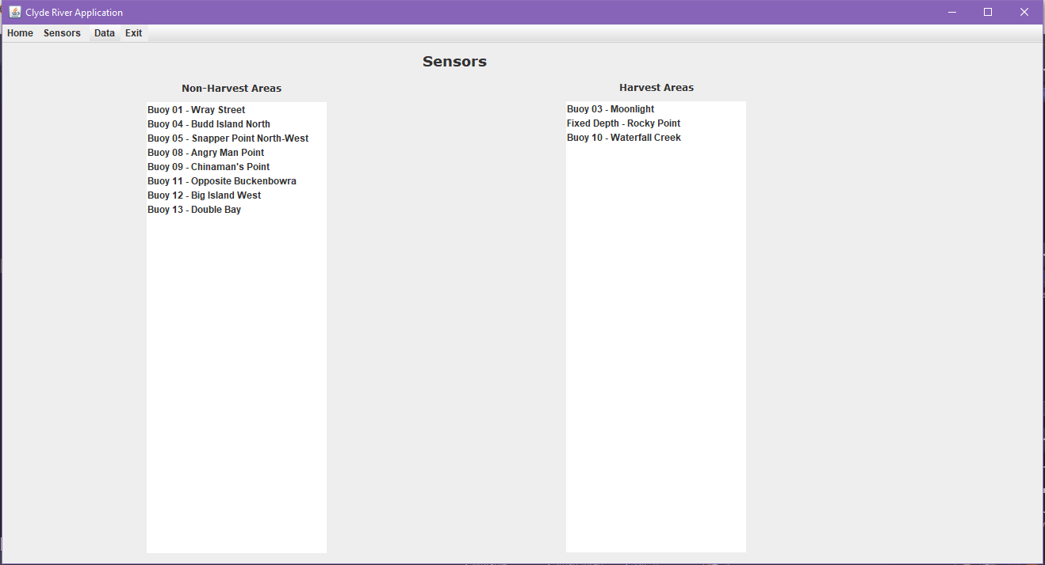

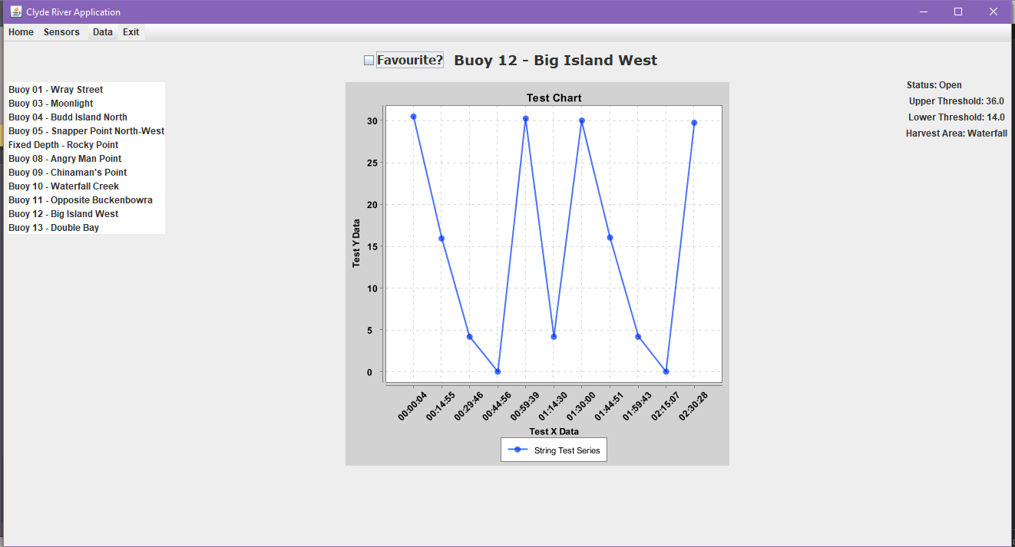

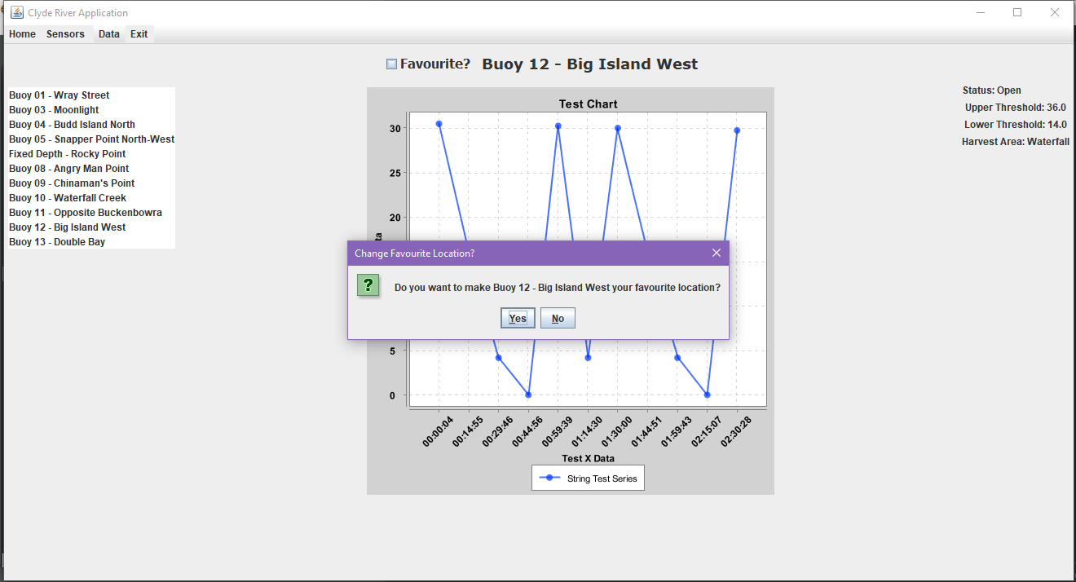

Result

